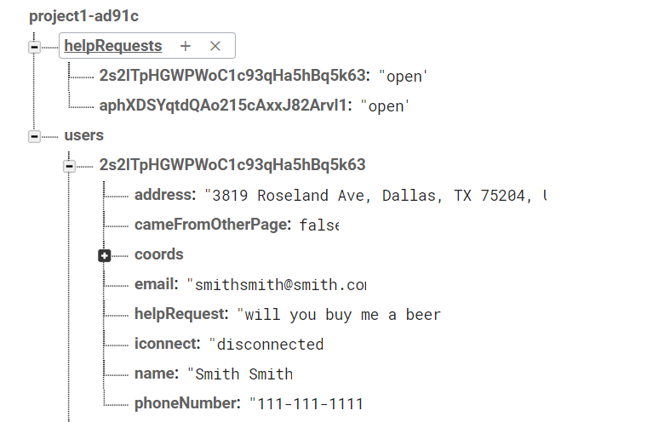

Make uid be a data attribute for each of the marker info window content

On the helper side, when a “Help!” button is clicked, the unique id of the person in need of help is stored in a variable so that we can go through the two step verification process and then push information to the database

How do we want to store someone volunteering to help?

Structure helpRequests differently

Keep the node as the uid

But then put two children in it

First is stuff that relates to help

Status of request (set by person needing help): open, withdrew or complete

Whether they are being helped: beingHelped will have value of true or false

Second is stuff that relates to helper

Uid of helper

Status of helper – this will be complete, withdrew, still in progress

Helper page note: Only want to map those that have databaseObj.helpRequests[helpUID].help.status = “open” and databaseObj.helpRequests[helpUID].help.beingHelped = false

We will also push into the helper’s users node, the uid of the person that they are helping

Helping – UID

This way we can go to check the status of the uid, see that it was withdrawn and then the user can

The helper can mark the request as being complete

Nothing happens in the help node yet

This will appear in some type of format on the help requester’s page

The help requester can confirm that the request is indeed complete

1. What happens when a person pushes a new request?
   1. New request gets pushed to helpRequests
   2. Set beingHelped to false
   3. Send request to user node
   4. Onvalue should pick this up and make a button on request page
2. What happens when a person enters into an agreement to help? what gets pushed?
   1. Sets helpRequests-uid-helper-status to inProgress
   2. Sets helpRequests-uid-help-beingHelped to true
   3. Sets helpRequests-uid-helper-uid to the helper’s uid
   4. Sets users-helperuid-serving to uid of person they are helping
   5. Triggers an on-value-change function on help request page that will detect that their request has a helper and will give information about that helper (distance away – need to set up distance api, phone number, name) – since this is real time updating, this will appear immediately
3. What happens when a helper marks the request as complete?
   1. Sets helpRequests-uid-helper-status to complete
   2. Doesn’t change helpRequests-uid-helper-uid yet >>still need this for help page info
   3. Removes the serving node from helper’s users-uid >> the user is no long helping
   4. Triggers an on-value-change function on help request page that will detect that their helper has marked the request as complete. The help requester can then choose to either withdraw their request, mark their request as complete or reopen request –
      1. All of these will remove helper from helpRequest
      2. Reopen will keep request, but will set beingHelped to false
      3. Complete will remove request, but will put status as withdrew in history
   5. Push to requestHistory-helper-uid-helperstatus of complete by you, date complete, uid of help requester, and request
      1. Push whatever status the requester marks it with to requestHistory-helper-uid-helperstatus and requestHistory-help-uid-helperstatus
4. What happens when a requester marks request as complete?
   1. First off, request should not be possible to mark complete unless request matched with user
   2. In helper’s user node and helpRequests-uid-help-status to Complete, mark status as complete
      1. This triggers a value change event and then we need to detect this and do something on the helper’s page